Convenient on-the-go storage solution

[Watch Video](https://www.kingston.com/en/video/play?videoId=zVtRWgAcfn4VVBL-CK13ViTXFiicRzWGf6-v6ront9QPps8gxKfHRwr_j1fXeYccIizeNJW7-glo1npp7n7Sng2&start=0&autoPlay=False&chromeless=False&captionOption=No)

DTXM

* [Intro](https://www.kingston.com/en/usb-flash-drives/datatraveler-exodia-m-moving-usb-3-2-usb-flash-drive#product-features)
* [Key Features](https://www.kingston.com/en/usb-flash-drives/datatraveler-exodia-m-moving-usb-3-2-usb-flash-drive#key-feature)
* [Specifications](https://www.kingston.com/en/usb-flash-drives/datatraveler-exodia-m-moving-usb-3-2-usb-flash-drive#specifications)
* [Resources](https://www.kingston.com/en/usb-flash-drives/datatraveler-exodia-m-moving-usb-3-2-usb-flash-drive#links)
* [Datasheet](https://www.kingston.com/datasheets/dtxm_us.pdf)

[**Buy**](https://www.kingston.com/en/usb-flash-drives/datatraveler-exodia-m-moving-usb-3-2-usb-flash-drive#atc)

DataTraveler Exodia M USB Flash Drivewith Moving Cap in Multiple Colors

Kingston DataTraveler® Exodia™ M is a USB 3.2 Gen 1 compliant storage solution for laptops, desktop PCs, monitors and other digital devices. DT Exodia M allows quick transfers and convenient storage of documents, music, videos and more. It’s available in multiple stylish color options that correspond by capacity up to 256GB1. Its practical design makes it an ideal on the go storage solution whether at work, home or school. DT Exodia M is backed by a five-year warranty, free technical support and legendary Kingston® reliability.

* Moving cap design protects USB connector
* Multiple color options by capacity
* Loop easily attaches to key rings

Key Features



Functional design

Moving cap design protects USB connector and your data when not in use.



Convenience at your fingertips

The lightweight USB 3.2 Gen 1 compliant storage solution delivers quick file transfers.



Ultimate portability

Range of capacities with colorful cap and a loop that easily attaches to key rings.

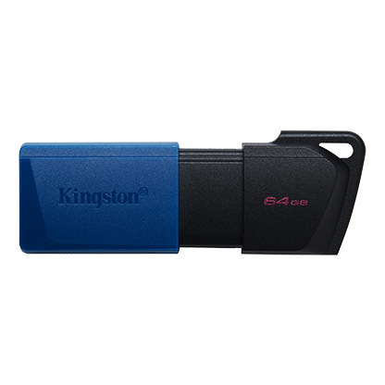

* [DataTraveler Exodia M 64GB](javascript:void(0))
* [DataTraveler Exodia M 64GB](javascript:void(0))
* [DataTraveler Exodia M 64GB](javascript:void(0))

Capacity

 64GB

 128GB

 256GB

Packaging

 Single Pack

 2 pack

* Part Number: DTXM/64GB
* USB 3.2 Gen 1 compliant
* 5-year warranty

[**Where to Buy**](https://www.kingston.com/en/wheretobuy)